S3 – Object Encryption
You can encrypt object in S3 buckets by 1 of 4 methods:
- Server-Side Encryption (SSE):
  - Server-Side Encryption with Amazon S3-managed keys (SSE-S3) – Enabled by default
- Server-side Encryption with KMS Keys stored in AWS KMS (SSE-KMS)
  - Leverage AWS Key management service
- Server-side Encryption with Customer-Provided Keys (SSE-C)
  - When you want to manage your own encryption keys
- Client-Side Encryption

S3 Encryption – Server-side Encryption with S3-managed keys (SSE-S3)
- Encryption using keys handled, managed and owned by AWS
- Object is encrypted server-side
- Encryption type is AES-256
- Must set header “x-amz-server-side-encryption”:”AES256”
- Enabled by default for new buckets & new objects
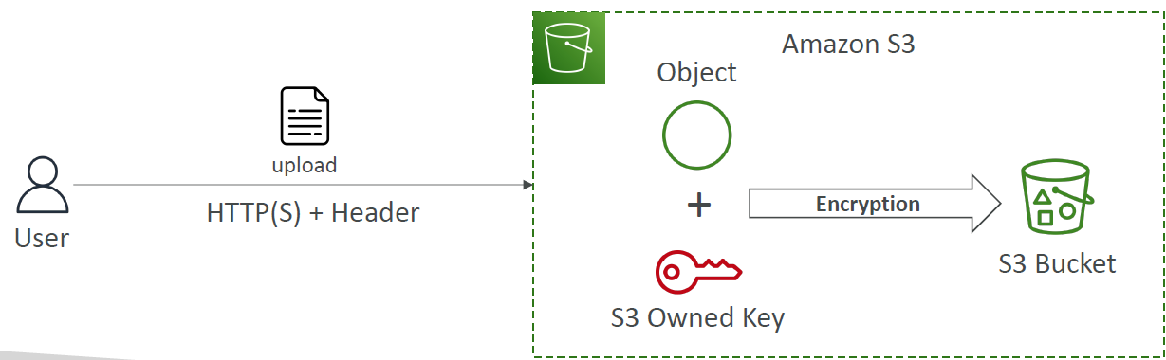

S3 Encryption - Server-side Encryption with KMS Keys stored in AWS KMS - SSE-KMS
- Encryption using keys handled and managed by AWS KMS (Key management service)
- KMS advantages: user control + audit key usage by using CloudTrail
- Object is encrypted server side
- Must set header “x-amz-server-side-encryption””aws:kms”
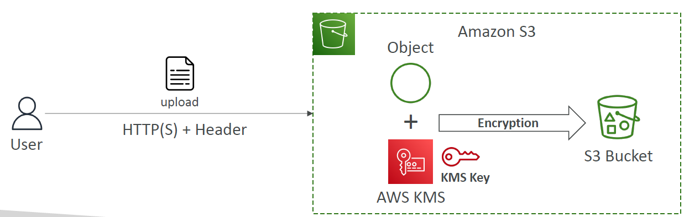
SSE-KMS limitation
To read the file from S3 buckets you need access to both the object and the KMS underlying the object too
- When using SSE-KMS, you may be impacted by KMS limits quotas
- When you upload it calls the GenerateDataKey KMS API
- When you download it calls Decrypt KMS API
- Count towards the KMS quota per second (5500, 10000, 30000 req/s based on region)
- You can request a quota increase using Service Quotas Console

S3 Encryption – Server-side Encryption with Customer-Provided Keys - SSE-C
- Server-side Encryption using keys fully managed by customer outside of AWS
- S3 does NOT store the encryption key you provide
- HTTPS is compulsory
- Encryption key must be provided in HTTP headers, for every HTTP request sent
- Flow: User upload file using HTTPS header request with encryption key in HTTP headers Then S3 uses Client’s provided key and the objects to perform Encryption Then puts the files as encrypted into the S3 bucket. To read the file, users must provide the same key was used for encryption in order to read the encrypted files.
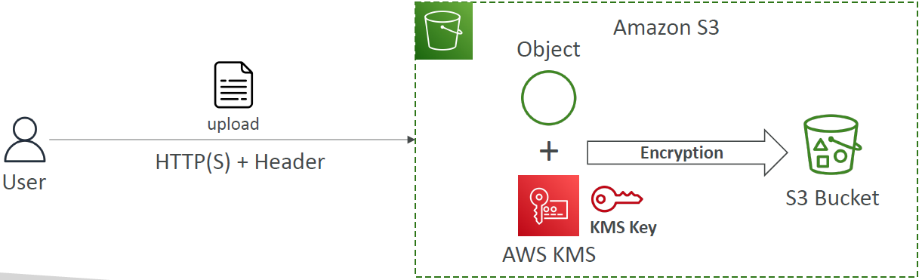

S3 Encryption – Client-Side Encryption
- Use client libraries such as Amazon S3 Client-side Encryption library
- Client must encrypt data themselves before sending it to S3
- Client must decrypt data themselves when retrieving from S3
- Customer fully manages the keys and encryption cycle
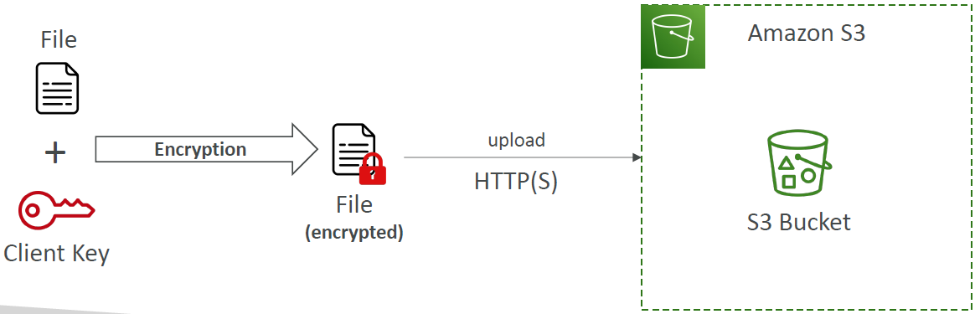

S3 Encryption in transit (SSL/TLS)
- Encryption in flight also known as SSL/TLS
- S3 exposes 2 endpoints:
  - HTTP Endpoint – non-encrypted
  - HTTPS Endpoint – encryption in flight
- HTTPS is recommended
- HTTPS is mandatory for SSE-C
- Most clients would use HTTPS endpoint by default

Force encryption in Transit aws:SecureTransport
You set Bucket Policy to: deny all GetObject requests if the aws “SecureTransport” false This mean all users using HTTP to GetObject will be blocked and only users using HTTPS endpoint to GetObject will be allowed to get the objects from S3 bucket.
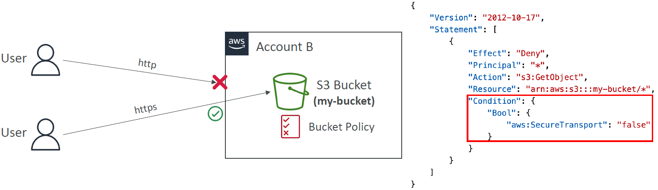

S3 Encryption Hands-on
Basically press Create bucket
In create S3 bucket > Enable Bucket versioning
In Default Encryption select one of the 3 Encryption type:
- Server-side encryption with Amazon S3 managed keys (SSE-S3)
- Server-side encryption with AWS Key Management Service keys (SSE-KMS)
- Dual-layer server-side encryption with AWS Key Management Service keys (DSSE-KMS)
  - (Secure your objects with two separate layers of encryption. For details on pricing, see DSSE-KMS pricing on the Storage tab of the)
Then Enable “Bucket key”
Then upload some files for testing
Result: Go into that object you uploaded to check for “Server-side encryption settings” section:
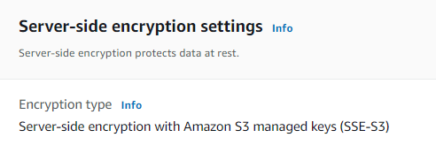
- You can also “Edit” Server-side encryption settings and change Encryption type too this will create a new version of the Object.

S3 – Default Encryption vs Bucket Policies
Default Encryption:
- SSE-S3 encryption is automatically applied to new objects stored in S3 bucket
- Optionally, you can force encryption using a bucket policy and refuse any API call to PUT an S3 object without encryption headers (SSE-KMS or SSE-C)
- Note: Bucket Policies are evaluated before “Default Encryption”
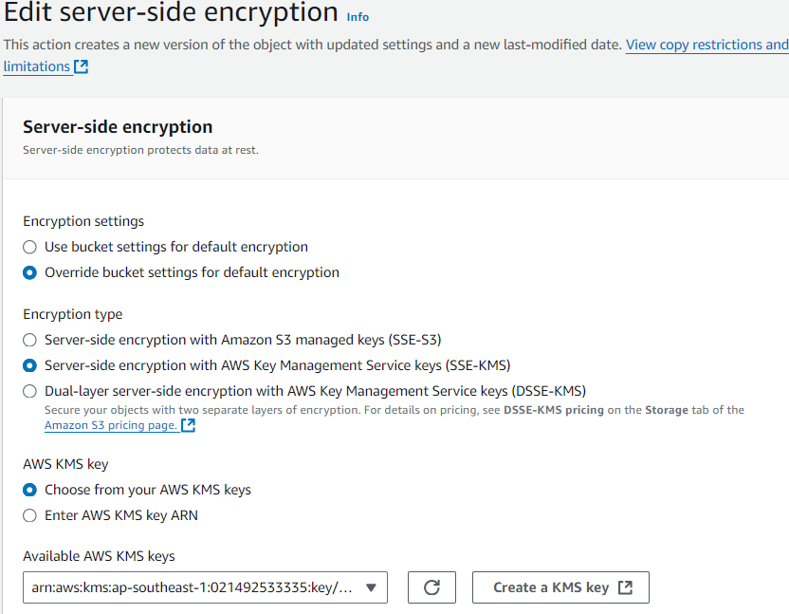
- Notes: By select Choose from your AWS KMS keys it will list default key for you to select for free. But if you want to Create a KMS key and select that custom key it WILL COST MONEY.
- Result: now it will have 2 objects version with Current version is the one you changed it to use SSE-KMS:
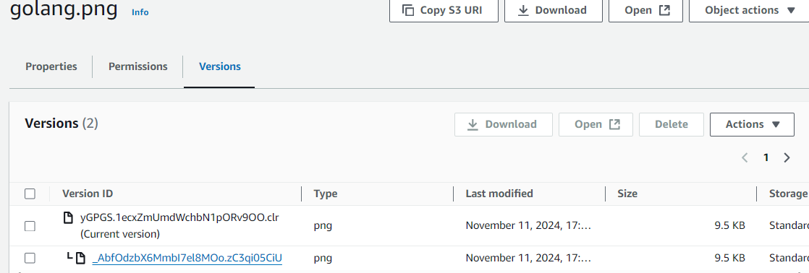
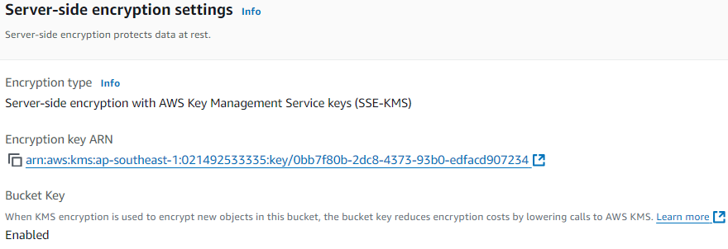

S3 CORS
- CORS : Cross-Origin Resource Sharing (CORS)
- Origin = scheme(protocol) + host(domain) + port
  - example: https://www.example.com (implied port is 443 for HTTPS, 80 for HTTP)
- Web Browser based mechanism allow requests to other origins while visiting the main origin

